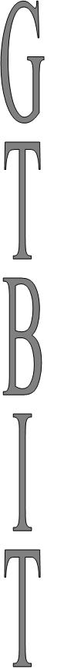
Design A Program To:
- Create A Tree
- Traverse It In Inorder
- Traverse It In Preorder
- Traverse It In Postorder
- Delete Leaf Node
- Delete Node With Single Child
- Delete Node With Two Childs
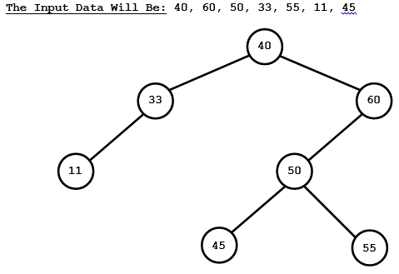
Program:
#include<stdio.h>
#include<conio.h>
#include<alloc.h>

struct BINARY_S_TREE
{
BINARY_S_TREE *left;
int info;
BINARY_S_TREE *right;
};

BINARY_S_TREE *root;

void CREATE_TREE(BINARY_S_TREE *loc, int data)
{
BINARY_S_TREE *FRESH;
if(data==loc->info)
{
printf("DUPLICATE VALUE OF NODE INFORMATION\n");
return;
}
else if(data<loc->info)
{
if(loc->left != NULL)
{
CREATE_TREE(loc->left,data);
}
else
{
printf("INSERTING TO LEFT\n");
FRESH=(BINARY_S_TREE *) malloc (sizeof(BINARY_S_TREE));
FRESH->info=data;
FRESH->left=FRESH->right=NULL;
loc->left=FRESH;
} }
else
{
if(loc->right != NULL)
{
CREATE_TREE(loc->right,data);
}
else
{
printf("INSERTING TO RIGHT\n");
FRESH=(BINARY_S_TREE *) malloc (sizeof(BINARY_S_TREE));
FRESH->info=data;
FRESH->left=FRESH->right=NULL;
loc->right=FRESH;
}
}
}

void INORDER(BINARY_S_TREE * root_loc)
{
BINARY_S_TREE *loc;
loc=root_loc;
if(loc!=NULL)
{
INORDER(loc->left);
printf("%d -> ",loc->info);
INORDER(loc->right);
}
}

void PREORDER(BINARY_S_TREE * root_loc)
{
BINARY_S_TREE *loc;
loc=root_loc;
if(loc!=NULL)
{
printf("%d -> ",loc->info);
PREORDER(loc->left);
PREORDER(loc->right);
}
}

void POSTORDER(BINARY_S_TREE * root_loc)
{
BINARY_S_TREE *loc;
loc=root_loc;
if(loc!=NULL)
40
33
11
60
50
45
55
{
POSTORDER(loc->left);
POSTORDER(loc->right);
printf("%d -> ",loc->info);
}
}

void DELETE_LEAF()
{
BINARY_S_TREE *loc,*par;
int item;
loc=root;
printf("\nENTER THE LEAF NODE TO BE DELETED ");
When To Delete Leaf Node; Simply Replace The Position Of Node To Be Deleted By The NULL Pointer.
scanf("%d",&item);
while(loc->info != item)
{
if(item<loc->info)
{
par=loc;
loc=loc->left;
}
40
33
11
60
50
45
else
{
par=loc;
loc=loc->right;
}
}

if(par->info > loc->info)
{
par->left=NULL;
}
else
{
par->right=NULL;
}
Node To Be Deleted Is 55
free (loc);
}

void DELETE_NODE_WITH_SINGLE_CHILD()
{
BINARY_S_TREE *loc,*par, *child;
int item;
loc=root;
printf("\nENTER THE NODE TO BE DELETED ");
scanf("%d",&item);
while(loc->info != item)
{
if(item < loc->info)
{
par=loc;
loc=loc->left;
}
else
{
par=loc;
loc=loc->right;
}
}

if(loc->left==NULL)
{
child=loc->right;
}
else
{
child=loc->left;
}

if(par->info > loc->info)
{
par->left=child;
}
else
{
par->right=child;
}
loc->right=loc->left=NULL;
free (loc);
}

void DELETE_NODE_WITH_TWO_CHILDS()
{
BINARY_S_TREE *loc,*par,*temp, *ptr, *ptrr, *child;
int item;
loc=root;
printf("\nENTER THE NODE TO BE DELETED ");
scanf("%d",&item);
while(loc->info != item)
{
if(item < loc->info)
{
par=loc;
loc=loc->left;
}
else
{
par=loc;
loc=loc->right;
}
}
Node Position to Be Deleted (25)
ptr=loc;
ptrr=loc->right;
As The INORDER Successor Of Any Node Is The Left Most Child In The Right Sub Tree Of That Node.
while(ptrr->left != NULL)
{
ptr=ptrr;
ptrr=ptrr->left;
}
Checking For Leaf Node
if(ptrr->left == NULL && ptrr->right == NULL)
{
if(ptr->info > ptrr->info)
{
ptr->left=NULL;
}
else
{
ptr->right=NULL;
}
}
Checking For Single Child Node
else if(ptrr->left !=NULL || ptrr->right !=NULL)
{
if(ptrr->left == NULL)
{
child = ptrr->right;
}
else
{
child = ptrr->left;
}

if(ptr->info > ptrr->info)
{
ptr->left=child;
}
else
{
ptr->right=child;
}
}

if(par == NULL)
{
root=ptrr;
Changing Position Of 33 With 25
}
else if(loc == par->left)
{
par->left=ptrr;
}
else
{
par->right=ptrr;
}
ptrr->left=loc->left;
ptrr->right=loc->right;
Deleting 25
free (loc);
}

void main()
{
clrscr();
int value;
char ch;
root=NULL;
root=new BINARY_S_TREE;
root->info=40;
root->left=root->right=NULL;
CREATE_TREE(root,60);
CREATE_TREE(root,50);
CREATE_TREE(root,33);
CREATE_TREE(root,55);
CREATE_TREE(root,11);
CREATE_TREE(root,45);
printf("\nINORDER DISPLAY\n");
INORDER(root);
printf("\nPREORDER DISPLAY\n");
PREORDER(root);
printf("\nPOSTORDER DISPLAY\n");
POSTORDER(root);
getch();
}

The Input Data Will Be: 40, 60, 50, 33, 55, 11, 45

40
33
11
60
50
45
55

Tree

Deletion Of Leaf Node
40
33
11
60
50
45
55

When To Delete Leaf Node; Simply Replace The Position Of Node To Be Deleted By The NULL Pointer.

40
33
11
60
50
45

Node To Be Deleted Is 55

Deletion Of Node With Single Child

40
33
11
60
50
45
55

When to Delete Node with Single Child; Simply Replace The Position Of That Node With Its Single Child Node

40
11
60
50
45
55

Node to Be Deleted Is 33

Deletion Of Node With Two Childs
60
25
15
75
50
33
44
66
60
33
15
75
50
44
66
When To Delete Node With Two Childs; Simply Replace The Node With Its Immediate Node In The INORDER Traversal.
Node To Be Deleted Is 25, Since As In The INORDER Traversal The Immediate Node After 25 Is 33 So 33 Will Replace 25.
NOTE:
- After Finding The Immediate Node (33)
- Check Whether 33 Is Leaf Node Or Single Child Node
- Adjust The Child Of 33 (If Any)
- Adjust 33 Inplace Of 25 And Add The Childs Of 25 To 33.
INORDER Traversal:
15, 25, 33, 44, 50, 60, 66, 75

